**Performance Modeling - RISC-V processor**

**This will be an INDIVIDUAL project**

**Phase 1: (Due November 7th 11:59PM)**

1) Draw the schematic for a single stage processor and fill in your code in the provided file to run the simulator.

2) Measure and report average CPI, Total execution cycles, and Instructions per cycle by adding performance monitors to your code. Make sure you output these values to a file.

3) What optimizations or features can be added to improve performance? (Extra credit)

Your code will be tested against 10 test cases. 3 of which will be released 5 days prior to your submission. (2nd November)

**Notes:**

1. **Please modify the existing code to use the correct way to handle folder paths. (Use os.path.join() instead of hardcoding OS dependent forward/back slashes).**
2. You’ll only submit a zipped folder named netID.zip

Make sure you follow the folder structure shown below.

Your code will be in one folder named netID with an entry point file (main.py or main.cpp).

There’ll be a second folder called input/ with each subfolder named testcase0/, testcase1, etc., and each of these test cases will contain 2 files, imem.txt and dmem.txt.

After running your code, a third folder should be created as an output folder with the name output_netID/ with subfolders named testcase0/, testcase1. Each subfolder must contain 4 files: PerformanceMetrics_Result.txt, SS_DMEMResult.txt, SS_RFResult.txt, StateResult_SS.txt.

1. A sample test case is already on brightspace under the project section.

Project root

|

|_ input/

| |_testcase0

| | |_imem.txt

| | |_dmem.txt

| |_testcase1

| | |_imem.txt

| | |_dmem.txt

| |_testcasen

| |_imem.txt

| |_dmem.txt

|

|_ netID/

| |_**main.py** (or) **main.cpp**

| |_additional_folders_and_files

| |_README (in case there’s anything you want to mention about your code/dependencies)

|

|_ output_netID/

|_testcase0

| |_PerformanceMetrics_Result.txt

| |_SS_DMEMResult.txt

| |_SS_RFResult.txt

| |_StateResult_SS.txt

|

|_testcasen

|_PerformanceMetrics_Result.txt

|_SS_DMEMResult.txt

|_SS_RFResult.txt

|_StateResult_SS.txt

Solve with your folder structure as:

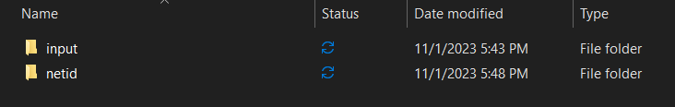

After running

$ python3 netid/main.py

The expected output folder structure should be as follows:

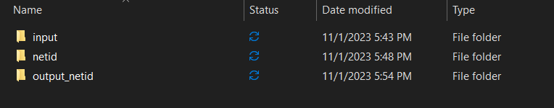

You will be submitting the zipped netid folder, and the PDF report along with it on brightspace. Do not upload the input/output folders.